
Directions
Travel north on the Glenn Highway to the junction with the Parks Highway. Turn west (left) onto the Parks Highway and follow it into Wasilla. Turn left (south) onto Knik-Goose Bay Road, which is an extension of Main Street. Main Street is to the left and Knik-Goose Bay is to the right (coming from Anchorage). Drive two blocks to Lakeview Avenue and turn right. Alaska's Lake Lucille Bed & Breakfast is located on the right-hand side of the street approximately 1/2 mile down. You will see our sign.
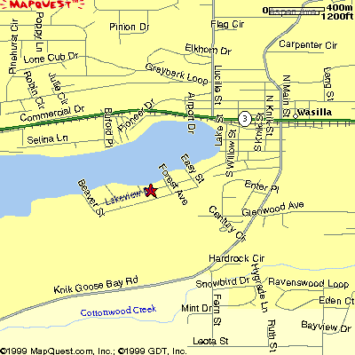
Alaska’s Lake Lucille Bed & Breakfast
235 West Lakeview Avenue
Wasilla, Alaska 99687
907-357-0352

Alaska’s Lake Lucille
Bed & Breakfast
Crafting & Painting Parties
Alaska's Lake Lucille Bed and
Breakfast is centrally located in the Matanuska-Susitna Valley, forty miles north of Anchorage.
We offer a quiet comfortable lakeside retreat.
Come and enjoy a wonderful crafting retreat with your friends. You will be glad you did.
Alaska's Lake Lucille Bed & Breakfast, located
less than one mile from main street Wasilla,
offers first class lakeside accommodations with
great mountain views for your
Alaskan Retreat with your friends.
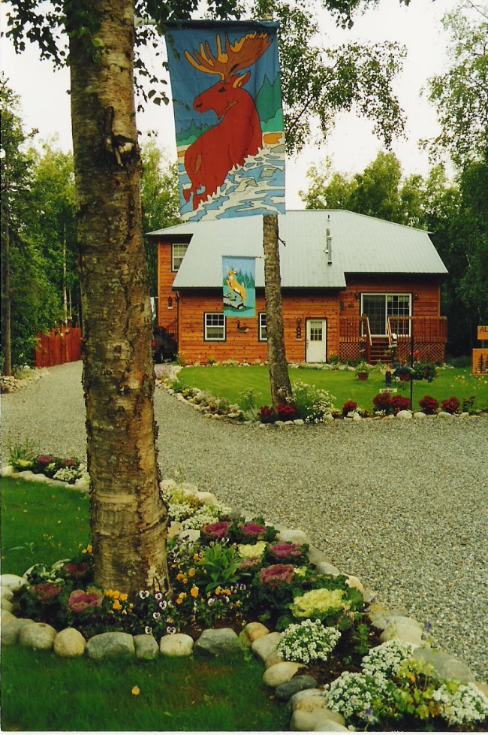

Our B&B is located in Wasilla on beautiful Lake Lucille, in the heart of the mountains of the Matanuska Valley; less than 50 miles from downtown Anchorage and on the way to everything. Our first class lakeside lodgings were designed to accommodate Alaska travelers who prefer a B&B atmosphere yet still want the privacy afforded by other accommodations.
Welcome...Stay at Home with us!
Our B&B has more than 1600 square feet of private space dedicated to our guests—including four LARGE bedrooms with Queen Size beds; the rooms easily accommodate the addition of a foldaway single sleeper or daybed. The bedrooms share three full bathrooms. We also can expand to two bedrooms and two suites with queen beds, private baths, and a sitting room that includes a television, microwave, refrigerator and love seats that double as a fold out single sleeper. The sitting room also can accommodate the addition of a foldaway single sleeper or daybed. There is a private entrance to the B&B for guest convenience.

Reservations:
Reservations are required and contingent on availability.
Method of payment:
Cash, Check or Credit Card
Painting, Quilt& Crafting Retreat Pricing Policies
*1 Night - $ 129.00 *2 Nights - $ 149.00
*Minimum group of 6 persons
*Half deposit per person required.
*Balance is due 15 days prior to arrival date.
Cancellation of less than 14 days is a loss of 50%
of your deposit. Cancellation of less than 7 days is a total
loss of your deposit.
Check in ~ Check out:
It is important that we know your time of arrival to assure a personal greeting for you from your host. Check-in time is 5:00 p.m., Friday evening. Checkout: 12:00 p.m., Sunday morning
Smoking Restrictions
Smoking is not permitted in the house.
Breakfast
You will have a complimentary continental breakfast which includes homemade breads and muffins, fruits, cereals, fresh fruit in season and a variety of beverages.
Relax in our comfortable rooms featuring rustic country decor and Alaskan art. All of the rooms are tastefully decorated with pictures and art highlighting the beauty of Alaska wildlife and scenery. Each room has common access to a living room furnished with a reclining sofa and two reclining chairs; a large 32-inch Sony stereo television with cable broadcasting, Netflix and Hulu.
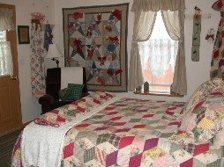
Alaska’s Lake Lucille B & B
is the perfect location for
Family Gathering and Reunions
Crafting & Quilting Retreats
Paint Parties
Retreats & Prayer Meetings
Bridal & Baby Showers
Stay at our charming Country Garden themed
B & B. Enjoy the homey atmosphere of
Crafting, Scrap Booking & Quilting with friends. Have exclusive use of the Bed and Breakfast and all of its amenities with a group of your friends.

Many Projects to Choose:
Crafting, Quilting, Sewing, Journaling
Jewelry Making, or Wood Projects.

What is a Craft & Sip?
This is a casual social gathering with friends that combines a little wine and creating instructor-led craft projects. Instruction is meant for artists and crafters at all levels…and even beginners. You can see examples of finished project on my website.

How is All Works
Contact me to schedule a date for your private party and to finalize the project. Check out the website to choose from the list of monthly projects.

I will provide the project pieces, paint, and all supplies needed to finish the project. I will also provide a continental breakfast and lunch on Saturday.

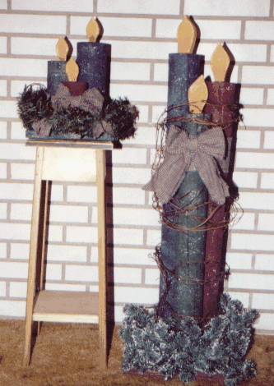

*Open year round.
*Prices starting from $129.00 per person
*6 Person minimum
*Choose from a one night, or two night stay
Friday and/or Saturday night.
*Craft Project & Stay and lunch
included in price.
*Showtime begins at 6:30 pm on Friday.
Bring an appetizer to share for your evening meal; you may bring in your own drinks if you wish. Soft drinks and crafting beginning at about 6:30 pm.
*Crafting until early morning hours.
*Choose several projects to make
throughout the retreat. You will be provided will several projects to make, this is a make and take Retreat. Additional projects can be provided at additional price. Ideas of projects can be viewed on line.
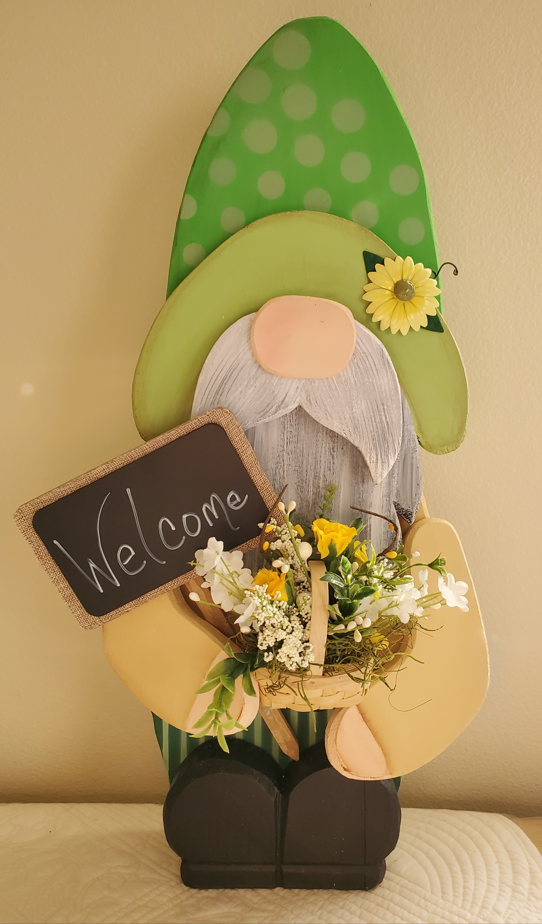
Bring an appetizer to share for your evening
meal; you may bring in your own drinks if you wish. Soft drinks and wine beginning at about 6:30 pm.
*Full and Satisfying continental breakfast..
*Pizza will be brought in from
Evangelos Italian Restaurant
for your lunch meal.

Check our website for more details.
http://www.alaskaslakelucillebnb.com
https://lakelucillebnb.com/ladies-retreats/

