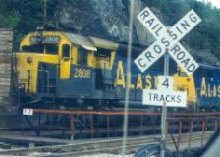
Directions
Travel north on the Glenn Highway to the junction with the Parks Highway. Turn west (left) onto the Parks Highway and follow it into Wasilla. Turn left (south) onto Knik-Goose Bay Road, which is an extension of Main Street. Main Street is to the left and Knik-Goose Bay is to the right (coming from Anchorage). Drive two blocks to Lakeview Avenue and turn right. Alaska's Lake Lucille Bed & Breakfast is located on the right-hand side of the street approximately 1/2 mile down. You will see our sign.
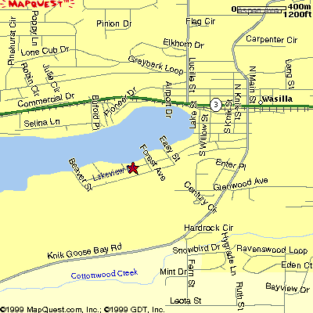
Your hosts at Alaska’s Lake Lucille Bed & Breakfast, Richard and Carol Smith, Alaskan residents.
*Member of the
-Wasilla Chamber of Commerce
-Alaska's Mat-Su B & B Association
- Mat-Su Convention & Visitors Bureau
Alaska’s Lake Lucille Bed & Breakfast
235 West Lakeview Avenue
P.O. Box 874162
Wasilla, Alaska 99687-4162
907-357-0352
Fax: 907-357-0353
Email:
yayacraftersclub@alaska.com
info@militaryspouseshq.com
Alaska’s Lake Lucille
Bed & Breakfast
Quilting & Crafting Retreats
Alaska's Lake Lucille Bed and
Breakfast is centrally located in the Matanuska-Susitna Valley, forty miles north of Anchorage.
We offer a quiet comfortable lakeside retreat.
Come and enjoy a wonderful crafting retreat with your friends. You will be glad you did.
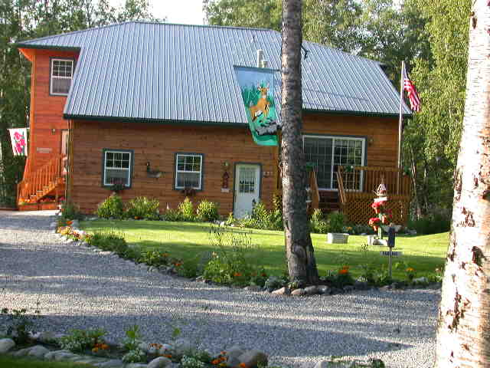

Alaska's Lake Lucille Bed & Breakfast, located less than one mile from main street Wasilla, offers first class lakeside accommodations with great mountain views for your Alaska Quilting Retreat with your friends.
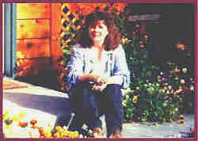
Welcome...Stay at Home with us!

Reservations:
Reservations are required and contingent on availability.

Method of payment:
Cash, money orders, Master Card and Visa American Express Traveler’s Checks.
Quilt& Crafting Retreat Pricing Policies
*Minimum group of 6 persons
*$60.00 deposit per person (minimum $360.00) required.
*Balance is due 15 days prior to arrival date.
Cancellation of less than 14 days is a loss of 50% of your deposit. Cancellation of less than 7 days is a total loss of your deposit.
Check in ~ Check out:
It is important that we know your time of arrival to assure a personal greeting for you from your host. If your time changes, please advise your host directly. Check-in time is 7:00 p.m. Checkout: 4:00 p.m.

Smoking Restrictions
Smoking is not permitted in the house. Smoking is allowed outside in the Picnic and BBQ Grill area.
Breakfast
You will have a complimentary continental or full breakfast. Continental includes rolls, cereal, fresh fruit in season and a variety of beverages, and our full breakfast is prepared from a varied menu and served in the dining room starting at 8:30 a.m. Menu selection includes pancakes, French toast, waffles, homemade breads and muffins, fruits, cereals, juices, coffee and tea. We will do our best to accommodate those with special dietary needs.
Our B&B is a newly built lodging in Wasilla on beautiful Lake Lucille, in the heart of the mountains of the Matanuska Valley; less than 50 miles from downtown Anchorage and on the way to everything. Our first class lakeside lodgings were designed to accommodate Alaska travelers who prefer a B&B atmosphere yet still want the privacy afforded by other accommodations.

Our B&B has more than 1600 square feet of private space dedicated to our guests—including four LARGE bedrooms with Queen Size beds; the rooms easily accommodate the addition of a foldaway single sleeper or daybed. The bedrooms share three full bathrooms. We also can expand to two bedrooms and two suites with queen beds, private baths, and a sitting room that includes a television, microwave, refrigerator and love seats that doubles as a fold out single sleeper. The sitting room also can accommodate the addition of a foldaway single sleeper or daybed. There is a private entrance to the B&B for guest convenience.
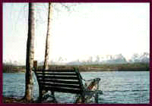
Relax in our comfortable rooms featuring rustic country decor and Alaskan art. All of the rooms are tastefully decorated with pictures and art highlighting the beauty of Alaska wildlife and scenery. Each room has common access to a living room furnished with a reclining sofa and two reclining chairs; a large 32-inch Sony stereo television with cable broadcasting and a VCR with a variety of video recordings available for guest viewing. The breakfast nook has a Microwave, refrigerator, and private pantry available for guest use.
Crafting & Quilt Retreat Weekend Packages
Come and relax with your of friends at Alaska's Lake Lucille Bed & Breakfast, for a relaxing crafting & quilt retreat. Craft and be pampered at the same time. Your evening stay will include a night of crafting on beautiful Lake Lucille. You and your friends will also be pampered to include Greek Pizza from Evangolos Italian Restaurant, wine & soft drinks as well as back massages, and eye waxing. Pedicure and manicures (arranged by request).
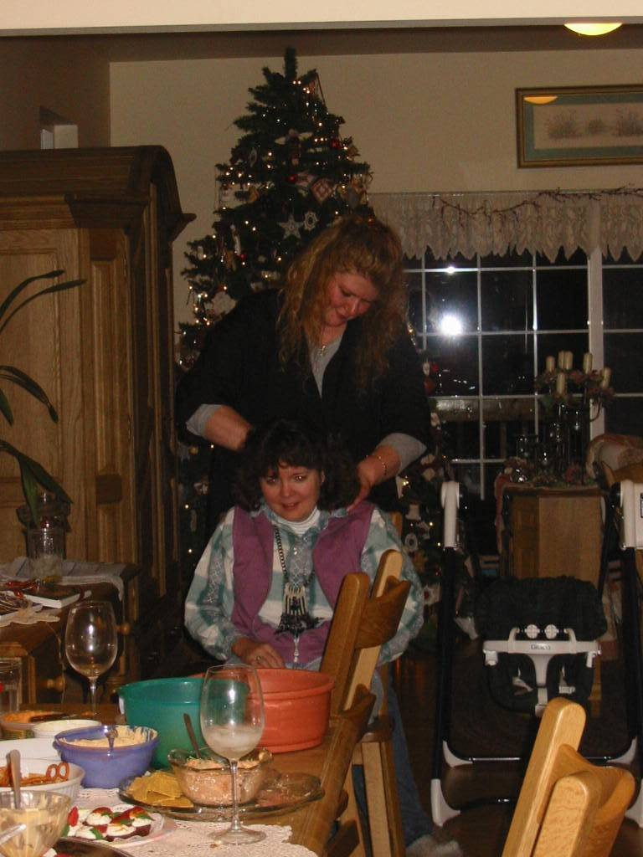
Our One Night / One Day Package includes:
*Showtime begins at 7:00 pm on Friday Evening with a Pizza Dinner from Evangelos Italian Restaurant, Soft drinks, and pampering beginning at about 8:30 pm.
*Back Massage and Eye brow waxing, back massages, and eye waxing. Pedicure and manicures (arranged by request).
*Crafting until early morning hours.
*Choose several projects to make through out the retreat.
*Full and Satisfying Gourmet breakfast/brunch.
*Afternoon tea, hot and cold beverages, and a fine selection of variety breads..
*Stamping and Card making until 4:00 pm.
*Leave totally pampered.
*Package cost is $140.00 / person (plus 7.5% tax) - 6 person minimum.

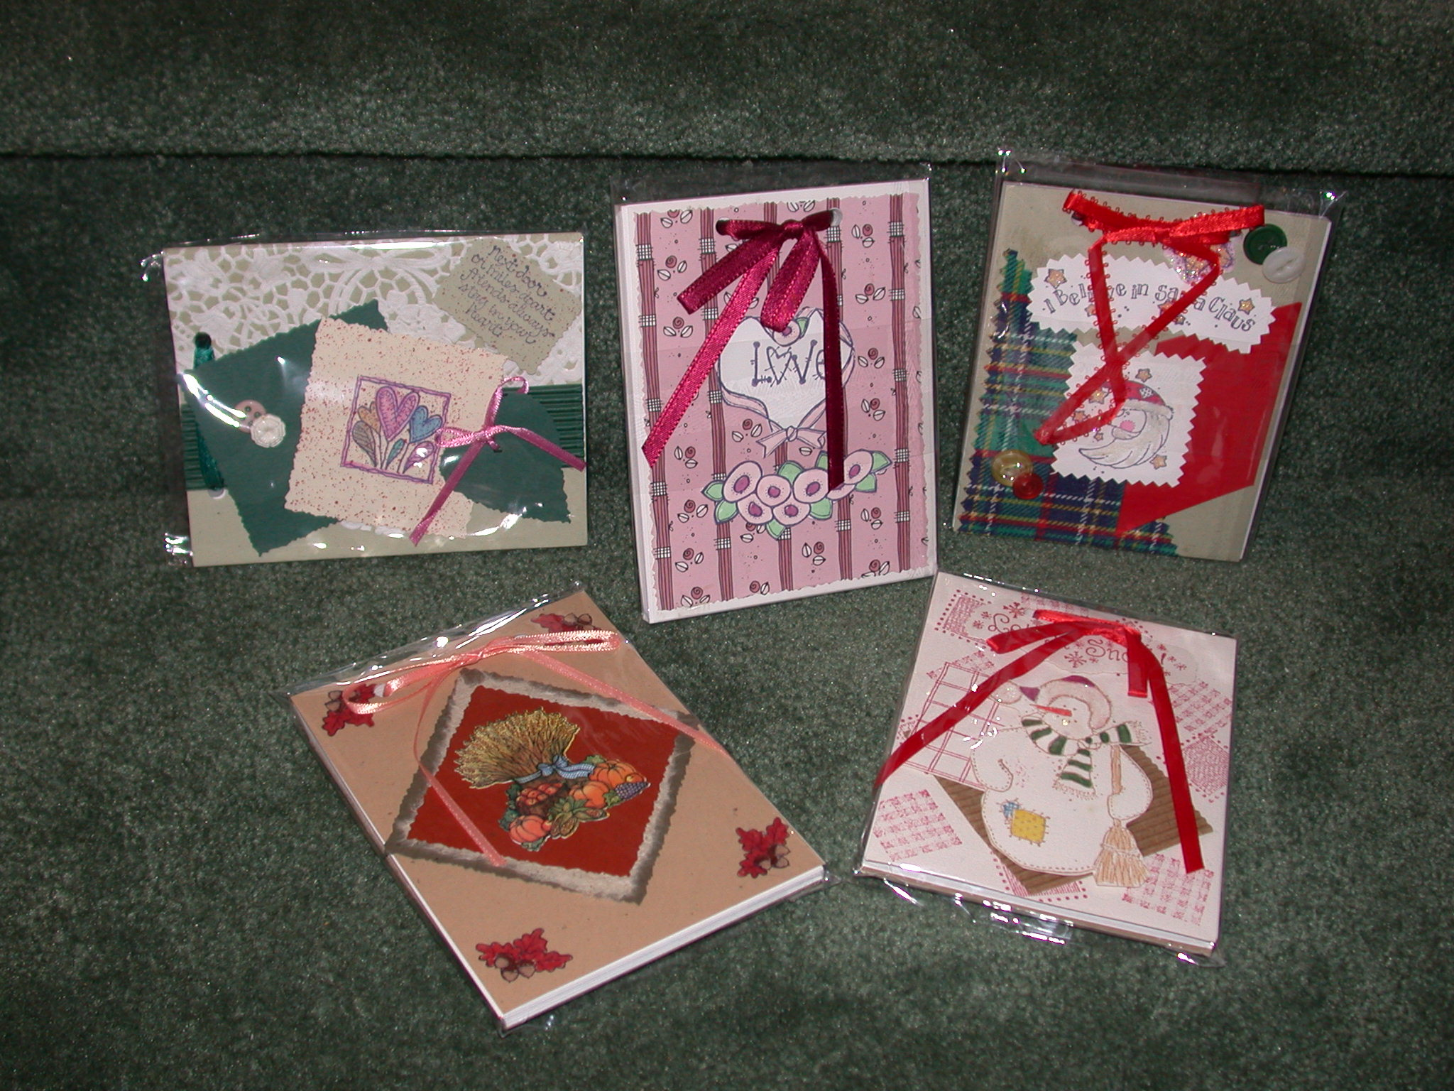
Many Crafting Projects to Choose:
*Bird House & Hearts
*Cards & Notepads
*Small Birdhouse
*Patriotic Sign
*Love, Laughter
*Moose
*Bird House Crate
*Yard Moose
*Cluster Trees
*Welcome Hearts
*Stacked Hearts
*Bears
*Quilt Stand-Small
*Quilt Stand-Large
*Table Decoration
*Winter Welcome
*Wall Birdhouse
*Table Top Birdhouse
*Welcome Wall Fence
*Wall Angel
*Moose Coat Rack
*Cluster Birdhouses
*Cabin Swag
*Welcome Shutter
*Primitive Angel
*Welcome Bear
Check our web site for more details.
CRAFTER’S CLUB
http://militaryspouseshq.com/crafters/index.html
mailto:info@militaryspouseshq.com
MILITARY SPOUSES, HQ
http://militaryspouseshq.com
mailto:info@militaryspouseshq.com

